University Of Engineering and Technology, Lahore
Computer Engineering Department

Course Name: Programming Fundamentals | Course Code: CMPE-112L
Assignment Type: Lab Report | Dated:
Semester: 1st | Session: 2026 Spring
Lab/Project/Assignment #: 10 | CLOs to be covered: CLO
Lab Title: QT Designer | Teacher Name: Hafiz Muhammad Mubashar
Lab Evaluation:

CLO1 | Apply appropriate programming techniques to create executable programs to solve well defined problems
 | Level1 | Level2 | Level3 | Level4 | Level5 | Level6
(5)
Total |  |  |  |  |  | /5
Rubrics for Current Lab Evaluation
Scale | Marks | Level | Rubric
Excellent | 5 | L1 | Submitted all lab tasks, BONUS task, have good understanding.
Very Good | 4 | L2 | Submitted the lab tasks but have good understanding
Good | 3 | L3 | Submitted the lab tasks but have weak understanding.
Basic | 2 | L4 | Submitted the lab tasks but have no understanding.
Barely Acceptable | 1 | L5 | Submitted only one lab task.
Not Acceptable | 0 | L6 | Did not attempt
LAB No 1
Lab Goals/Objectives:
• Understand the purpose of Qt Designer.
• Learn to create graphical user interfaces (GUIs).
• Design windows, buttons, labels, and input fields.
• Integrate Qt Designer with Python programs..

Equipment Required:
- Computer/Laptop
- Python 3.x
- Qt Designer
- PyQt5/PySide6
- IDE (VS Code, PyCharm, or IDLE)

Theory:

Qt Designer is a visual tool used to create graphical user interfaces (GUIs) by dragging and dropping widgets. The designed interface is saved as a .ui file, which can be loaded into Python using PyQt5 or PySide6 to build interactive desktop applications.

Lab Work:

Qt Designer:

Task 1

Login page for University Portal

Result:

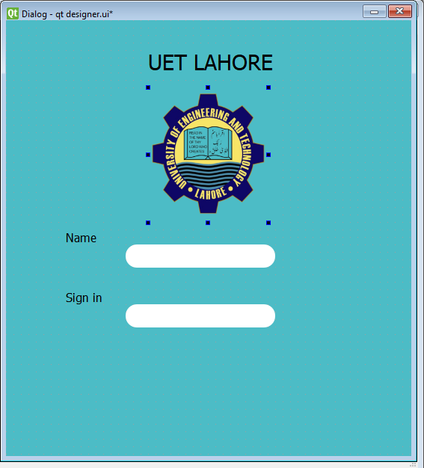

Conclusions:

In this lab, we learned how to design user interfaces using Qt Designer and connect them with Python applications. This enables the development of user-friendly and interactive desktop programs.

